HW 9 Report
- Reviewer feedback mostly changed the schematic. I did a bad job of having a clean and understandable schematic so I cleaned that up a lot. There were some concerns over traces but due to the time in my schedule I was not able to fully fix them. However, I believe that the current routing should not affect the boards functionality too much.
- It did not change how I updated my BOM. I was planning on hand soldering my board so I just added the manufacturer part number. This allowed me to upload the list to digi-key and not have any problems.
- 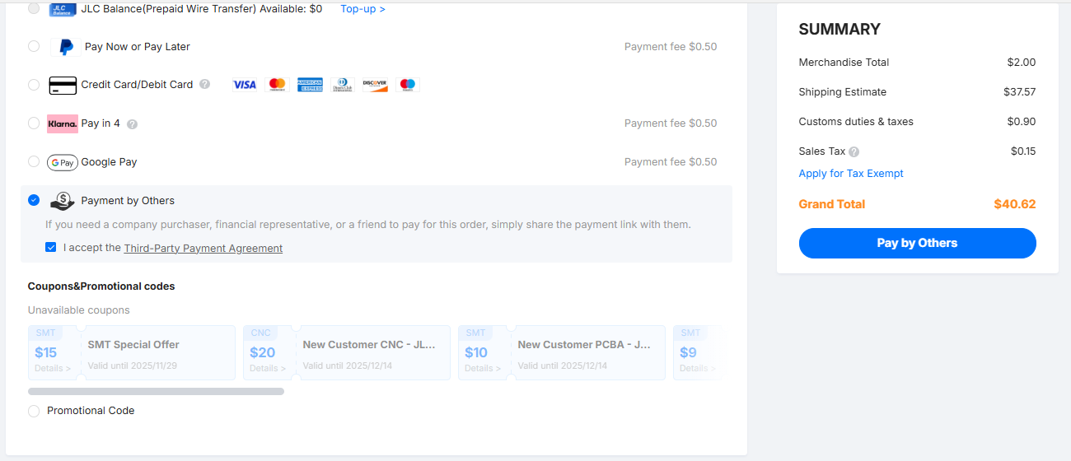
 | Sourced | References | MFR PN | Quantity
1 |  | C3, C6, C7, C9, C14, C16, C17, C18, C19, C20, C22, C23, C25, C26, C27, C29, C30, C31, C32, C33 | CCL31B105KOFNNNE | 20
2 |  | C8, C21, C28, C34 | GMC31X7R104K16NT | 4
3 |  | C15 | GMC31X7R225K16NT | 1
4 |  | C24 | 1206B224K500CT | 1
5 |  | R6, R7, R8, R13, R15, R16, R22, R23, R24, R25, R27, R28 | RC1206FR-0710KL | 12
6 |  | R1, R2, R3, R4, R9, R10, R11, R12 | RMCF1206JT300R | 8
7 |  | R5, R14, R21, R26 | RC1206FR-07249KL | 4
8 |  | R17, R18, R19, R20 | RC1206JR-0747RL | 4
9 |  | U1, U2, U3, U6, U7, U8 | MCP6002 | 6
10 |  | U4 | LM2664M6X/NOPB | 1
11 |  | U5 | ADS130B04-Q1 | 1
12 |  | 3_3v+, -3_3V, AIN0N, AIN0P, GND, GND, GND, M1+, M1-, M4+, M4-, SCLK, VinA+, VinA+, VinA+, VinB+, VinB+, VoutA |  | 18
13 |  | c1, c2, c4, c5, c10, c11, c12, c13 | 1206B103K500CT | 8
14 |  | M1 | 3SM123C4T1QA | 1
15 |  | M2 | 3SM123C4T1QA | 1
16 |  | M3 | 3SM123C4T1QA | 1
17 |  | M4 | 3SM123C4T1QA | 1
18 |  | J1 | PHED-RS006G1ABOGA-C006 | 1

Final Budget: 84.96

